# Mortality

Slashpine: Although the fixed effects accounted for regular mortality because of suppression and competition for resources, the plot-level random effect accounted for the effects of other unmeasured plot-level variables.

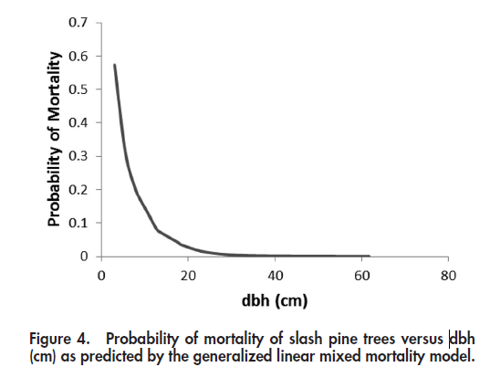 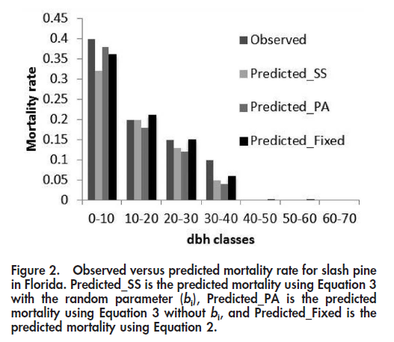

Longleaf:

lm(formula = log10(Observed_Diameter/Modeled_Diameter) ~ log10(Age),

data = final_list_longleaf)

Residuals:

Min 1Q Median 3Q Max

-0.09542 -0.04677 0.01428 0.03501 0.08277

Coefficients:

Estimate Std. Error t value Pr(>|t|)

(Intercept) -0.44128 0.09749 -4.526 0.000261 ***

log10(Age) 0.28255 0.05624 5.024 8.82e-05 ***

Residual standard error: 0.05219 on 18 degrees of freedom

Multiple R-squared: 0.5837, Adjusted R-squared: 0.5606

F-statistic: 25.24 on 1 and 18 DF, p-value: 8.818e-05

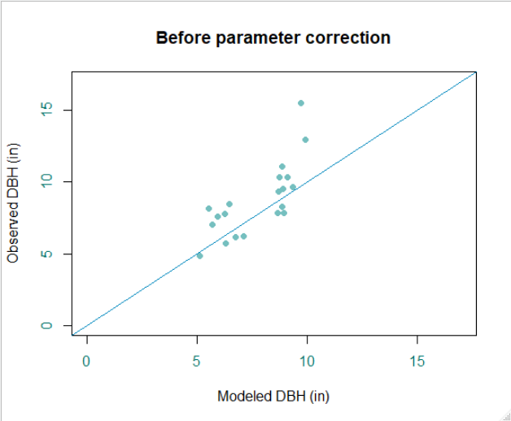 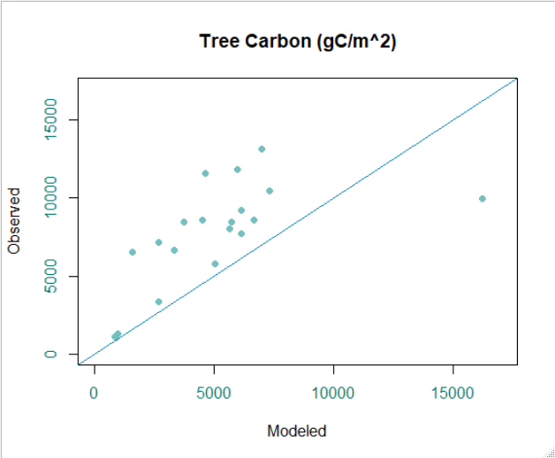

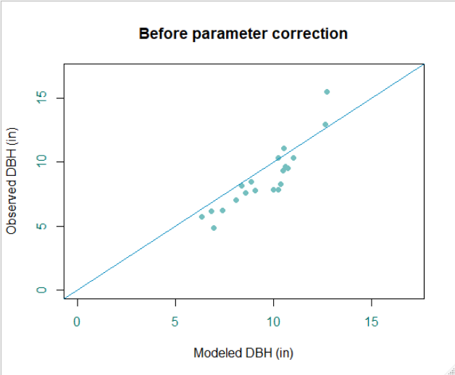 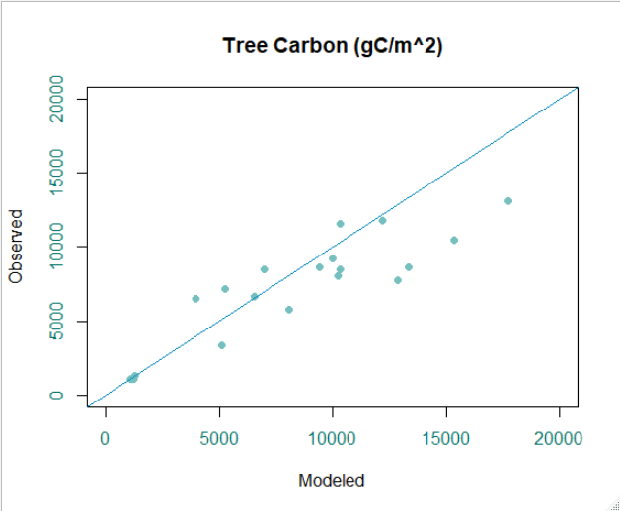

lm(formula = Observed_Biomass ~ Modeled_Biomass, data = final_list_longleaf)

Residuals:

Min 1Q Median 3Q Max

-5130.3 -1398.0 516.9 1464.5 3764.6

Coefficients:

Estimate Std. Error t value Pr(>|t|)

(Intercept) 3.604e+03 9.739e+02 3.700 0.001638 **

Modeled_Biomass 4.060e-01 8.573e-02 4.736 0.000165 ***

Residual standard error: 2398 on 18 degrees of freedom

Multiple R-squared: 0.5548, Adjusted R-squared: 0.5301

F-statistic: 22.43 on 1 and 18 DF, p-value: 0.0001648

Call:

lm(formula = Observed_Diameter ~ Modeled_Diameter, data = final_list_longleaf)

Residuals:

Min 1Q Median 3Q Max

-1.81149 -0.63521 0.04014 0.69607 2.70554

Coefficients:

Estimate Std. Error t value Pr(>|t|)

(Intercept) -3.3109 1.3388 -2.473 0.0236 *

Modeled_Diameter 1.2675 0.1386 9.146 3.46e-08 ***

Residual standard error: 1.092 on 18 degrees of freedom

Multiple R-squared: 0.8229, Adjusted R-squared: 0.8131

F-statistic: 83.65 on 1 and 18 DF, p-value: 3.464e-08